# AS/400 CSV Extract Steps (Non-JAVA option)

1. After logging on to the AS400, use command **EXTRACT** and hit **ENTER**, it will submit a batch job **EXTRACTCSV** in the background.

1. You may check the status of the job using WRKACTJOB command.

1. Below is how the running job will be displayed (use function key F5 to refresh this screen).

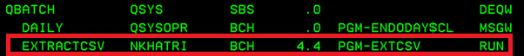

1. Once the job completes, it will have all the files created in folder “/home/csvdata”. To check that folder, you may use IBM Access Client Solution -> Actions -> Integrated File System as shown below.

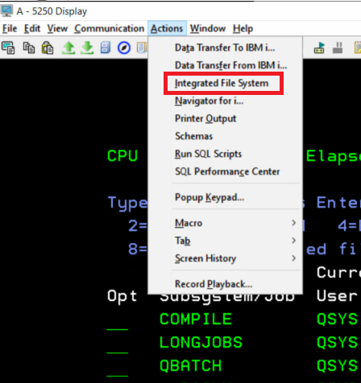

1. Change the directory location to /home/csvdata, here all the csv files will be available. This folder is recreated every time the job is run.

**AS400 Program list**

Below are the programs written for this utility which extracts all the 137 identified tables into CSV format.

|  |  |  |  |  |  |
| --- | --- | --- | --- | --- | --- |
| **Source Library** | **Source PF** | **Member** | **Type** | **Description** | **OBJECT Library** |
| NKHATRI | QCLSRC | EXTRACT | CMD | Command to extract CSV | QGPL |
| NKHATRI | QCLSRC | CALLEXT | CLLE | Call extract | QGPL |
| NKHATRI | QCLSRC | EXTCSV | CLLE | Extract Datafiles into CSV format | PIOLIB |
| NKHATRI | QCLSRC | EXTF5502 | CLLE | Extract F5502 File | PIOLIB |
| NKHATRI | QRPGLESRC | CPYPFR | RPGLE | Copy PF with decimal field data issues | PIOLIB |
| - | - | - | - | Output file for DSPOBJD | JDEDTAALL |

Sample CSV snapshot.

**=== End of document ===**